**Create Your first python App and Dockerise**



This page shows you how to do the following:

1. Create a Hello World app version 2 App.
2. Run it locally as service
3. Dockerise the application
4. Create python repo in Google container registry
5. Push python Version 2 image to GCR and Deploy the container image

**step 1 : review main.py ( this is your hello world python application)**

vim main.py

change “Hello from python” to Hello I am version 1 and then save file

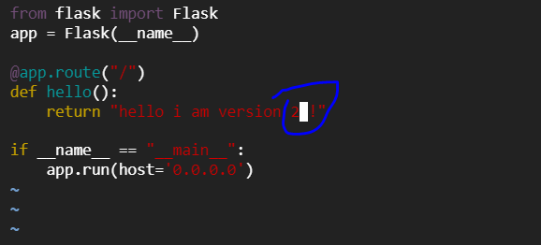

### **Step 3 : Create a Dockerfile or You can use existing**

cat Dockerfile

**Step 4 : build docker image version2**

docker buildx build -t anilbidari/python:v2 .

**Step-5: Now we have to push the image. Run the below command.**

docker push anilbidari/python:v2

**Step-6: We can see that it is pushed.**

**Step-7 : deploy v2 app as container**

docker run -d --name c2 -p 6002:80 anilbidari/python:v2

**step 8 : verify app1 is running**

curl http://localhost:6002



**step 9 : delete both containers**

docker rm -f c1 c2



**=================================== Completion of Lab ==================================**